Heptagonal Prismoid

Definition
# Source: AI Source: Provided by: [Data Path: Persons Table -> ID Column: 1, Name_En Column: Motasem Essam] -> From: [ChatGPT] on [7/25/2026]
A Heptagonal Prismoid is a three-dimensional polyhedron belonging to the Prismoid family, characterized by two heptagonal bases lying in parallel planes and connected by seven quadrilateral lateral faces.
The two bases have seven sides each but do not necessarily have the same size, shape, or orientation. The lateral faces are trapezoids or parallelograms.
It has 9 faces, 21 edges, and 14 vertices.

Geometric Structure
# Source: AI Source: Provided by: [Data Path: Persons Table -> ID Column: 1, Name_En Column: Motasem Essam] -> From: [ChatGPT] on [7/25/2026]
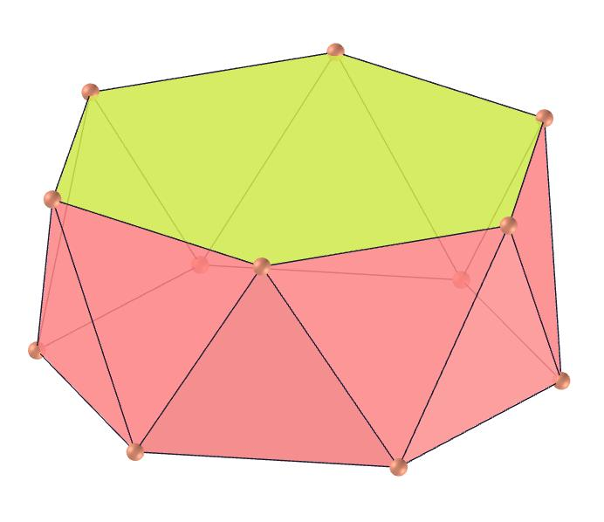
The solid consists of the following elements:
- Lower Heptagonal Base: A seven-sided polygon forming the bottom of the solid.
- Upper Heptagonal Base: A heptagon parallel to the lower base.
- Lateral Faces: Seven quadrilateral faces connecting corresponding edges of the two bases.
- Lateral Edges: Seven edges connecting corresponding vertices of the bases.
- Altitude (Height): The perpendicular distance between the two base planes.
- Midsection: A heptagonal cross-section parallel to both bases, halfway between them.

Face Composition
# Source: AI Source: Provided by: [Data Path: Persons Table -> ID Column: 1, Name_En Column: Motasem Essam] -> From: [ChatGPT] on [7/25/2026]
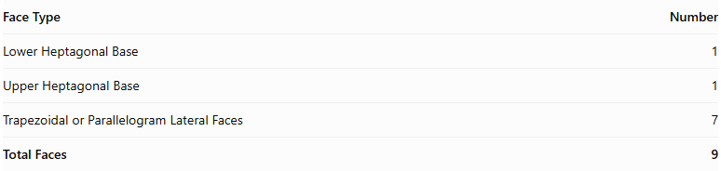
Face Type | Number
Lower Heptagonal Base | 1
Upper Heptagonal Base | 1
Trapezoidal or Parallelogram Lateral Faces | 7
Total Faces | 9
The seven lateral faces may be trapezoids or parallelograms, depending on the relative positions and orientations of the bases.

Mathematical Properties
# Source: AI Source: Provided by: [Data Path: Persons Table -> ID Column: 1, Name_En Column: Motasem Essam] -> From: [ChatGPT] on [7/25/2026]
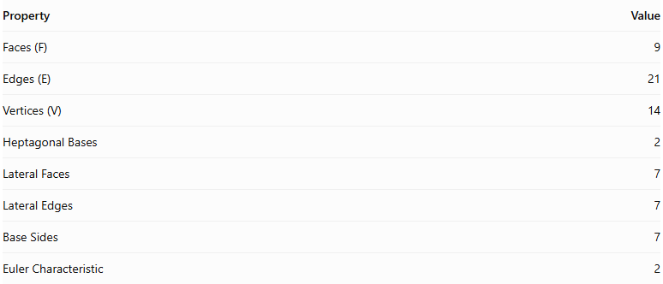
Property | Value
Faces (F) | 9
Edges (E) | 21
Vertices (V) | 14
Heptagonal Bases | 2
Lateral Faces | 7
Lateral Edges | 7
Base Sides | 7
Euler Characteristic | 2
Euler characteristic:
$$V-E+F=14-21+9=2$$
Volume Formula:
$$\boxed{V=\frac{h}{6}(A_{1}+4A_{m}+A_{2})}$$
Where:
- $V$ = Volume.
- $h$ = Perpendicular height.
- $A_{1}$ = Area of the lower heptagonal base.
- $A_{2}$ = Area of the upper heptagonal base.
- $A_{m}$ = Area of the heptagonal midsection.

Geometric Characteristics
# Source: AI Source: Provided by: [Data Path: Persons Table -> ID Column: 1, Name_En Column: Motasem Essam] -> From: [ChatGPT] on [7/25/2026]
- Heptagonal Bases: Both parallel bases have seven sides and seven vertices.
- Quadrilateral Lateral Faces: The solid has seven trapezoidal or parallelogram lateral faces.
- Variable Base Geometry: The upper and lower heptagons may differ in dimensions and shape.
- Inclined Lateral Edges: The connecting edges may be inclined relative to the base planes.
- Convex Structure: In its conventional form, the solid has a convex closed surface.
- Variable Configurations: Its appearance depends on the shapes, dimensions, and relative positions of its two bases.

Types of Heptagonal Prismoids
# Source: AI Source: Provided by: [Data Path: Persons Table -> ID Column: 1, Name_En Column: Motasem Essam] -> From: [ChatGPT] on [7/25/2026]
Heptagonal prismoids can be further classified according to the shapes and relationships of their bases:
- Regular Heptagonal Prismoid
- Irregular Heptagonal Prismoid
- Similar-Bases Heptagonal Prismoid
- Non-Similar-Bases Heptagonal Prismoid

Constructing a Heptagonal Prismoid

Geometric Instruments
# Source: AI Source: Provided by: [Data Path: Persons Table -> ID Column: 1, Name_En Column: Motasem Essam] -> From: [ChatGPT] on [7/25/2026]
The following instruments can be used to construct a heptagonal prismoid using traditional geometric drawing methods:
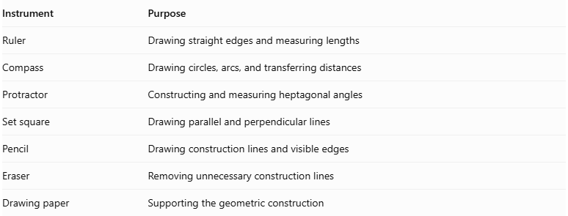
Instrument | Purpose
Ruler | Drawing straight edges and measuring lengths
Compass | Drawing circles, arcs, and transferring distances
Protractor | Constructing and measuring heptagonal angles
Set square | Drawing parallel and perpendicular lines
Pencil | Drawing construction lines and visible edges
Eraser | Removing unnecessary construction lines
Drawing paper | Supporting the geometric construction
Important note about the regular heptagon: An exact regular heptagon cannot be constructed using only an unmarked straightedge and compass. A protractor or another suitable measuring or construction instrument is needed for an exact practical drawing; alternatively, a compass-and-ruler approximation can be used.

Instrument-Based Construction Procedures

Method 1: Constructing from Two Parallel Heptagonal Bases
# Source: AI Source: Provided by: [Data Path: Persons Table -> ID Column: 1, Name_En Column: Motasem Essam] -> From: [ChatGPT] on [7/25/2026]
- Draw the lower heptagonal base $ABCDEFG$.
- If using a regular heptagon, construct its seven sides with a protractor, using an interior angle of approximately ${128.571}^{°}$.
- Establish the required perpendicular height above the lower base.
- Draw the upper heptagonal base $A'B'C'D'E'F'G'$ in a plane parallel to the lower base.
- Choose the dimensions and positions of the upper heptagon so that the corresponding connecting edges produce planar lateral quadrilaterals.
- Connect $A$ to $A'$.
- Connect $B$ to $B'$.
- Connect $C$ to $C'$.
- Connect $D$ to $D'$.
- Connect $E$ to $E'$.
- Connect $F$ to $F'$.
- Connect $G$ to $G'$.
- Join the corresponding base edges to complete the seven lateral quadrilaterals.
- Erase unnecessary construction lines and distinguish visible edges from hidden edges.

Method 2: Constructing from a Heptagonal Base and Its Parallel Upper Section
# Source: AI Source: Provided by: [Data Path: Persons Table -> ID Column: 1, Name_En Column: Motasem Essam] -> From: [ChatGPT] on [7/25/2026]
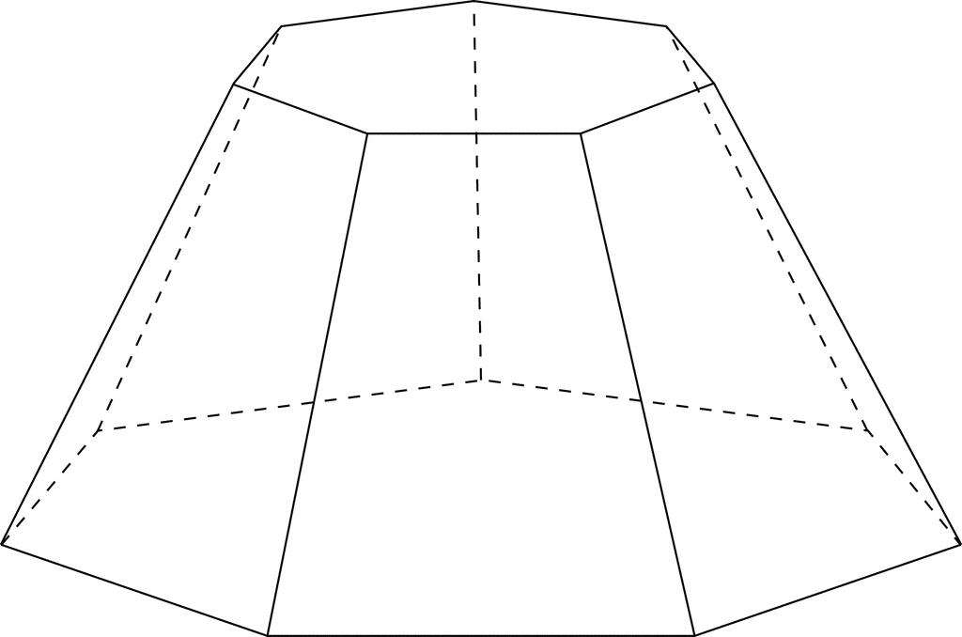
- Construct a heptagon $ABCDEFG$ as the lower base.
- Draw a parallel upper construction plane at the required perpendicular height.
- Construct a second heptagon $A'B'C'D'E'F'G'$ on the upper plane.
- Determine the corresponding positions of the seven upper vertices.
- Check that each pair of corresponding base edges and connecting lateral edges defines a planar quadrilateral.
- Connect the corresponding vertices.
- Complete all seven lateral faces.
- Verify that the upper and lower bases are parallel.
- Finalize the drawing by removing auxiliary lines and marking visible and hidden edges.

Method 3: Constructing Through Parallel Cross-Sections
# Source: AI Source: Provided by: [Data Path: Persons Table -> ID Column: 1, Name_En Column: Motasem Essam] -> From: [ChatGPT] on [7/25/2026]
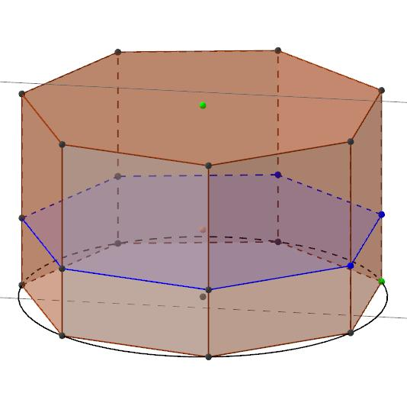
- Draw the lower heptagonal base $ABCDEFG$.
- Establish the perpendicular height of the solid.
- Mark the halfway level between the two bases.
- Construct a middle heptagonal cross-section $A_{m}B_{m}C_{m}D_{m}E_{m}F_{m}G_{m}$, parallel to the bases.
- Construct the upper heptagonal base $A'B'C'D'E'F'G'$.
- Connect the corresponding vertices of the lower, middle, and upper heptagons.
- Ensure that the resulting lateral faces are planar quadrilaterals.
- Complete the visible and hidden edges.
The middle cross-section is important for calculating the volume using the prismoidal formula. Its area must be obtained from the actual geometry.

Related Geometric Solids
# Source: AI Source: Provided by: [Data Path: Persons Table -> ID Column: 1, Name_En Column: Motasem Essam] -> From: [ChatGPT] on [7/25/2026]
- Heptagonal Prism – A special case with congruent parallel heptagonal bases.
- Heptagonal Pyramidal Frustum – A related solid with similar heptagonal bases.
- Heptagonal Prismatoid – The broader related geometric category.

Main Classification
# Source: AI Source: Provided by: [Data Path: Persons Table -> ID Column: 1, Name_En Column: Motasem Essam] -> From: [ChatGPT] on [7/25/2026]
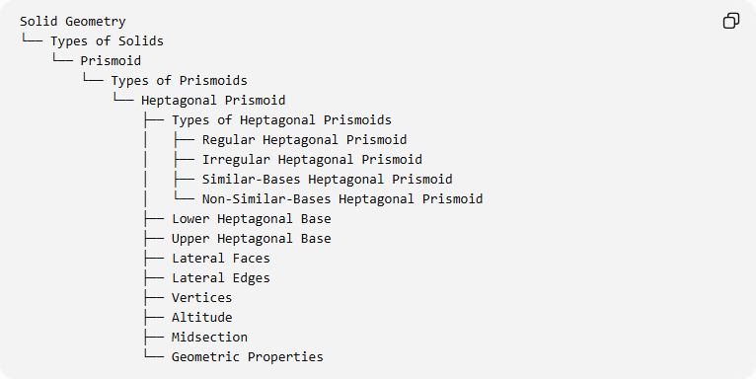
Solid Geometry
└── Types of Solids
└── Prismoid
└── Types of Prismoids
└── Heptagonal Prismoid
├── Types of Heptagonal Prismoids
│ ├── Regular Heptagonal Prismoid
│ ├── Irregular Heptagonal Prismoid
│ ├── Similar-Bases Heptagonal Prismoid
│ └── Non-Similar-Bases Heptagonal Prismoid
├── Lower Heptagonal Base
├── Upper Heptagonal Base
├── Lateral Faces
├── Lateral Edges
├── Vertices
├── Altitude
├── Midsection
└── Geometric Properties

Key Points
# Source: AI Source: Provided by: [Data Path: Persons Table -> ID Column: 1, Name_En Column: Motasem Essam] -> From: [ChatGPT] on [7/25/2026]
- A Heptagonal Prismoid has two parallel heptagonal bases.
- It contains seven quadrilateral lateral faces.
- It has 9 faces, 21 edges, and 14 vertices.
- Its bases may differ in size, shape, and orientation.
- Its lateral faces are trapezoids or parallelograms.
- It can have regular or irregular heptagonal bases.
- Its volume is calculated using the prismoidal formula.

Conclusion
# Source: AI Source: Provided by: [Data Path: Persons Table -> ID Column: 1, Name_En Column: Motasem Essam] -> From: [ChatGPT] on [7/25/2026]
The Heptagonal Prismoid is the seven-sided-base member of the Prismoid family. Its two parallel heptagonal bases and seven quadrilateral lateral faces define its geometric structure, allowing different configurations according to the shapes and dimensions of its bases.

